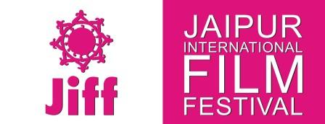
47, Saket Nagar (Shyam Nagar), New Sanganer Road, Jaipur – 302 019, Rajasthan, INDIA
www.jiffindia.org +91-141-6500601 jiffindia@gmail.com info@jiffindia.org

Press release (6 August, 2015)
Noted Screen Writer Kamlesh Pandey to Head JIFF 2016
Jaipur: 6 August, 2015: Noted screen writer Mr. Kamlesh Pandey will head the next Jaipur International Film Festival (JIFF) to be held in Jaipur from January 2nd to 6th 2016.
It was announced by JIFF spokesperson Rajendra Bora after the JIFF Board meeting here today.
Accepting the JIFF’s request Mr. Pandey, an Indian screen-writer and advertising professional with more than 30 years of experience in films, television and advertising, said in a communication : “Thank you for inviting me to become the Chairperson of the 8th Jaipur International Film Festival to be held between Jan.2-6, 2016, I confirm the same.
“It would be truly an honour and privilege for me to chair such an prestigious international festival”, he said in his acceptance communication.
Mr. Pandey, winner of Filmfare Award for Tezaab, Star Screen Award for ‘Saudagar’ and IIFA Award for ‘Rang De Basanti’, had been visiting JIFF for the last two consecutive years.
JIFF 2015 would be organized from 2-6 January, 2016 in Jaipur.
For more details about JIFF:
www.jiffindia.org
http://www.jiffindia.org/jiffteam.html
http://www.jiffindia.org/delegateregistration.html

Yours

Rajendra Bora
Spokesperson-JIFF
Mob: +91-9829051075

